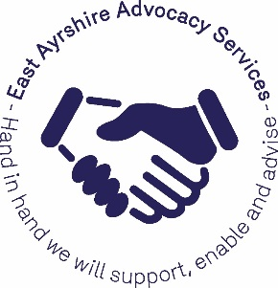

EAST AYRSHIRE ADVOCACY SERVICES

ADVOCACY WORKER (CHILDREN’S HEARING SYSTEM)

JOB DESCRIPTION

The two new advocates will be expected to build trusting relationships with children and young people to ensure that their views are heard and considered when they are in contact with the Children’s Hearing System.

The advocates will:

- Provide relevant information in a way that suits children and young people regarding their rights and what to expect at a Children’s Hearing and what options they have

- Actively support children and young people including those with Additional Support Needs to participate in decisions that affect their lives

- Help children to raise/resolve any concerns they have regarding their care or how they’ve been treated

- Speak on behalf of children or young people who are unable to do so themselves

- Support children and young people to gain the skills and confidence to advocate for themselves

- Support children and young people to give their views/experience of the Children’s Hearing System in order to inform/improve/develop the provision

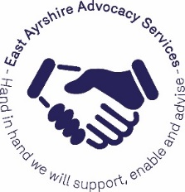

EAST AYRSHIRE ADVOCACY SERVICES

ADVOCACY WORKER FOR CHILDREN AND YOUNG PEOPLE IN THE CHILDREN’S HEARING SYSTEM – PERSON SPECIFICATION

Qualifications

- No formal qualifications required
- Understanding of and commitment to the principles of independent advocacy as per the S.I.A.A Principles & Standards and Code of Practice
- Good general education
- Knowledge and understanding of the GIRFEC approach and Child Protection procedures
- Good knowledge of The Scottish Government’s Advocacy Guidance and the National Practice Model for Advocacy in the Children’s Hearing System
- Current driving licence (and use of a car preferable)
- Ability to work flexible hours dependent on the needs of the children and young people who access the service

Experience and Skills:

- Experience of working with children and young people who meet the criteria for service and an understanding of the difficulties faced by them
- Experience of communicating effectively with children and young people with a range of conditions and difficulties ability to actively support them to participate in decisions that affect their lives
- Good interpersonal skills and ability to work as part of a team
- Basic IT and ability to manage own workload
- Sensitive approach to conflict, problem solving and confidentiality
- Knowledge of current legislation and policy affecting those who might use the service
- Experience of facilitating groups
- Ability to build trusting advocacy relationships with children and young people

